CLOUD COMPUTING LAB RECORD
SaaS Applications built using Zoho Creator – Experiments 1 to 11

Experiment 1: Flight Reservation System

Aim
To create a simple cloud software application for a Flight Reservation System using Zoho Creator as the Cloud Service Provider to demonstrate the SaaS model, including the necessary fields such as one way, round trip, From, To, Departure, Return, Travelers & Class, Fare Type, and International and Domestic flights.

Application design
Form: Flight_Booking
S.No | Field Label | Field Type | Sample Value
1 | Trip Type | Radio | Round Trip
2 | Flight Type | Radio | Domestic
3 | From | Dropdown | Chennai (MAA)
4 | To | Dropdown | Delhi (DEL)
5 | Departure Date | Single Line | 05-Nov-2026
6 | Return Date | Single Line | 09-Nov-2026
7 | Adults (12+ yrs) | Single Line | 2
8 | Children (2-11 yrs) | Single Line | 1
9 | Infants (below 2 yrs) | Single Line | 0
10 | Travel Class | Dropdown | Economy
11 | Fare Type | Dropdown | Regular
12 | Passenger Name | Single Line | Arun Kumar
13 | Phone | Single Line | +91 98765 43210
14 | Email | Single Line | arun.kumar@example.com
15 | Total Fare (Rs.) | Formula (read-only) | 26,950

Procedure
- Sign in to Zoho Creator (creator.zoho.com / creator.zoho.in), click Create Application, choose "Create from scratch" and name it "SkyWay Flight Reservation".
- Create a new form named Flight_Booking and drag and drop the fields listed in the table for this form. Mark calculated fields as read-only. Click Save.
- Add the Deluge script "On User Input of Trip_Type: show Return Date only for round trips" in the Form Builder under Workflow (Script Builder), as shown in the script section below.
- Add the Deluge script "On Validate: fare calculation" in the Form Builder under Workflow (Script Builder), as shown in the script section below.
- Click "Access Application" to open Live mode and enter the sample records in each form.
- Open the auto-generated reports and verify that the data, calculated fields and totals are correct.
- Use the Share / Publish option to create a permalink, then open it in a browser to show that the application runs as SaaS in the cloud.

Deluge scripts
On User Input of Trip_Type: show Return Date only for round trips
if (input.Trip_Type == "Round Trip")
{
show Return_Date;
}
else
{
hide Return_Date;
}

On Validate: fare calculation
// Fare_Master stores the one-way economy fare for each route
rec = Fare_Master[Route == input.From + " - " + input.To];
base = rec.Base_Fare;
if (input.Travel_Class == "Business")
{
base = base * 2.5;
}
total = (base * input.Adults) + (base * 0.75 * input.Children);
if (input.Trip_Type == "Round Trip")
{
total = total * 2;
}
input.Total_Fare = total;

Fare rule used in the sample: child fare = 75% of adult fare, infants travel free, round trip = 2 x one-way fare. Example (FLT-001): base Rs. 4,900 x 2 adults + Rs. 3,675 x 1 child = Rs. 13,475 one way; Rs. 26,950 round trip.

Output
Output 1: Flight Booking form (sample entry)
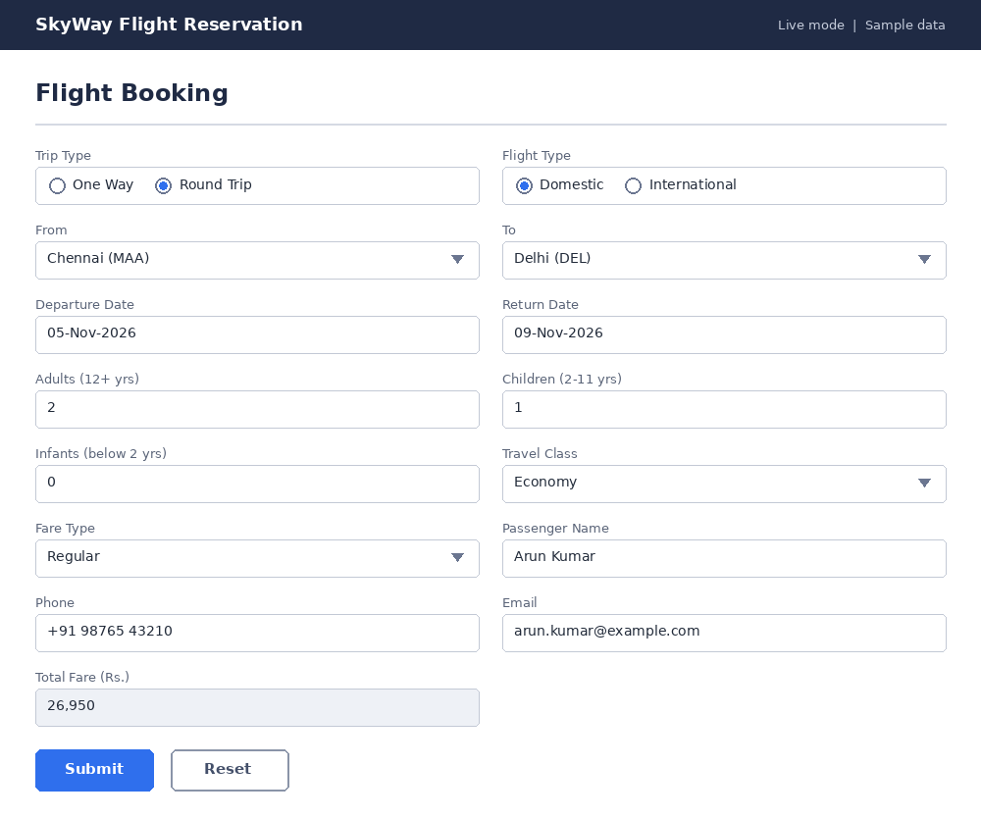
Output 2: Flight Bookings Report
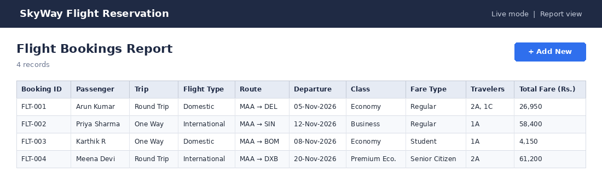

Result
Thus, the Flight Reservation System application was created and executed successfully on Zoho Creator. It was accessed through a web browser without any local installation, demonstrating the Software as a Service (SaaS) model.

Experiment 2: Property Buying & Rental System (Chennai)

Aim
To create a simple cloud software application for Property Buying & Rental process in Chennai city using Zoho Creator as the Cloud Service Provider to demonstrate the SaaS model, including the necessary fields such as Buy, Rent, Commercial, Rental Agreement, Area, Place, Range and Property Value.

Application design
Form: Property_Listing
S.No | Field Label | Field Type | Sample Value
1 | Listing Type | Radio | Rent
2 | Property Type | Dropdown | Apartment (2 BHK)
3 | Area / Locality | Dropdown | Velachery
4 | Place / Address | Single Line | Velachery Main Road, Chennai - 600042
5 | Built-up Area (sq.ft) | Single Line | 1,050
6 | Budget Range (Rs.) | Dropdown | 20,000 - 30,000 per month
7 | Property Value / Monthly Rent (Rs.) | Single Line | 28,000
8 | Security Deposit (Rs.) | Single Line | 1,40,000
9 | Rental Agreement | Radio | Yes
10 | Agreement Period | Dropdown | 11 Months
11 | Agreement Start Date | Single Line | 01-Nov-2026
12 | Agreement End Date | Formula (read-only) | 31-Oct-2027
13 | Owner Name | Single Line | S. Ramesh
14 | Contact Number | Single Line | +91 98400 12345

Procedure
- Sign in to Zoho Creator (creator.zoho.com / creator.zoho.in), click Create Application, choose "Create from scratch" and name it "Chennai Property Hub".
- Create a new form named Property_Listing and drag and drop the fields listed in the table for this form. Mark calculated fields as read-only. Click Save.
- Add the Deluge script "On User Input of Listing_Type: show or hide rental fields" in the Form Builder under Workflow (Script Builder), as shown in the script section below.
- Add the Deluge script "On Validate: agreement end date for rental properties" in the Form Builder under Workflow (Script Builder), as shown in the script section below.
- Click "Access Application" to open Live mode and enter the sample records in each form.
- Open the auto-generated reports and verify that the data, calculated fields and totals are correct.
- Use the Share / Publish option to create a permalink, then open it in a browser to show that the application runs as SaaS in the cloud.

Deluge scripts
On User Input of Listing_Type: show or hide rental fields
if (input.Listing_Type == "Buy")
{
hide Security_Deposit;
hide Rental_Agreement;
hide Agreement_Period;
}
else
{
show Security_Deposit;
show Rental_Agreement;
show Agreement_Period;
}

On Validate: agreement end date for rental properties
if (input.Rental_Agreement == "Yes")
{
input.Agreement_End_Date = input.Agreement_Start_Date.addMonth(11).subDay(1);
}

A residential rental agreement is normally made for 11 months; commercial leases are usually longer (the sample uses 36 months).

Output
Output 1: Property Listing form (sample entry)
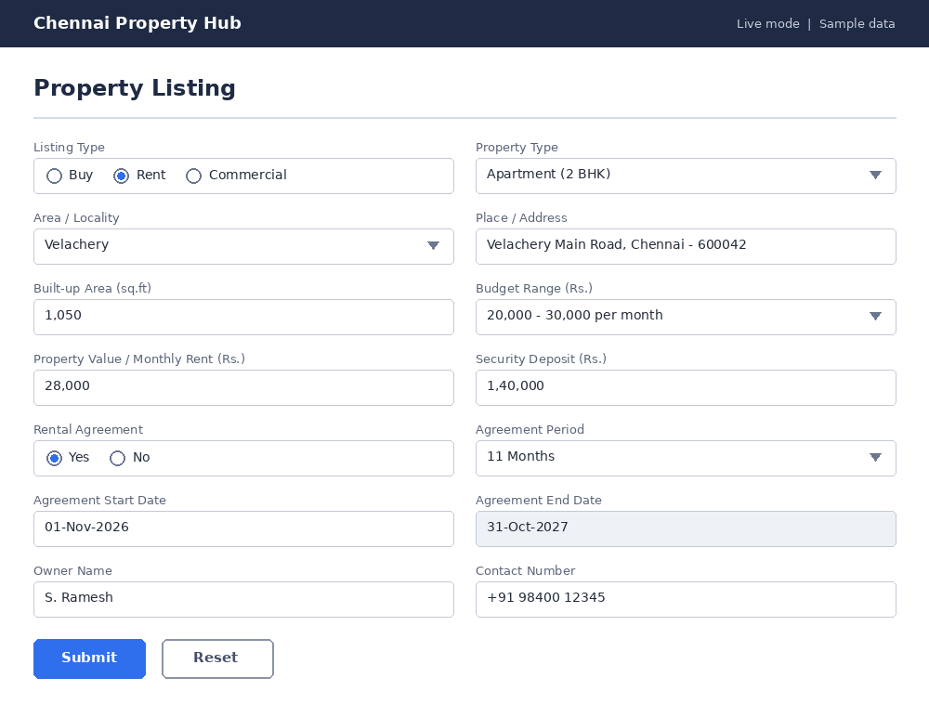
Output 2: Property Listings Report
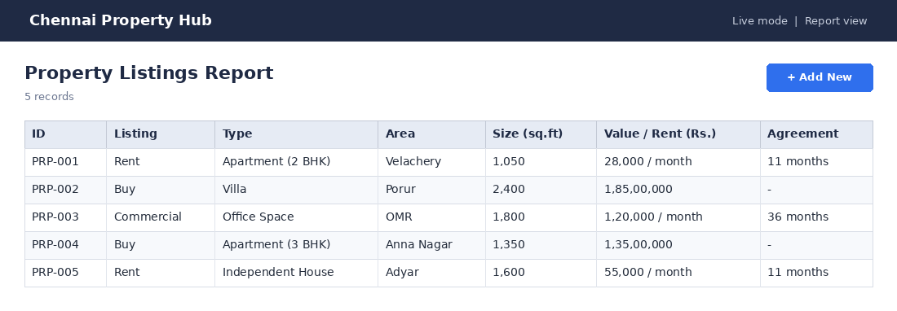

Result
Thus, the Property Buying & Rental System (Chennai) application was created and executed successfully on Zoho Creator. It was accessed through a web browser without any local installation, demonstrating the Software as a Service (SaaS) model.

Experiment 3: Car Booking Reservation System

Aim
To create a simple cloud software application for a Car Booking Reservation System using Zoho Creator as the Cloud Service Provider to demonstrate the SaaS model, including the necessary fields such as search for cabs, From, To, Rental, Outstation, Package type and Hours/Days.

Application design
Form: Cab_Booking
S.No | Field Label | Field Type | Sample Value
1 | Service Type | Radio | Outstation
2 | Trip Type | Radio | Round Trip
3 | From | Single Line | Chennai
4 | To | Single Line | Pondicherry
5 | Pickup Date | Single Line | 15-Nov-2026
6 | Pickup Time | Single Line | 06:30 AM
7 | Package Type | Dropdown | Outstation - Per Day (250 km)
8 | Duration Type | Radio | Days
9 | Duration | Single Line | 2
10 | Cab Type | Dropdown | SUV (Innova)
11 | Customer Name | Single Line | Karthik R
12 | Phone | Single Line | +91 90030 45678
13 | Estimated Fare (Rs.) | Formula (read-only) | 7,800

Procedure
- Sign in to Zoho Creator (creator.zoho.com / creator.zoho.in), click Create Application, choose "Create from scratch" and name it "QuickCab Reservation".
- Create a new form named Cab_Booking and drag and drop the fields listed in the table for this form. Mark calculated fields as read-only. Click Save.
- Add the Deluge script "On Validate: fare estimate" in the Form Builder under Workflow (Script Builder), as shown in the script section below.
- Click "Access Application" to open Live mode and enter the sample records in each form.
- Open the auto-generated reports and verify that the data, calculated fields and totals are correct.
- Use the Share / Publish option to create a permalink, then open it in a browser to show that the application runs as SaaS in the cloud.

Deluge scripts
On Validate: fare estimate
if (input.Service_Type == "Outstation")
{
// per-day rates
rate = 2800; // Hatchback
if (input.Cab_Type.contains("Sedan")) { rate = 3200; }
if (input.Cab_Type.contains("SUV")) { rate = 3900; }
input.Estimated_Fare = rate * input.Duration;
}
else
{
// per-hour rates for local rental
hourly = 250; // Hatchback
if (input.Cab_Type.contains("Sedan")) { hourly = 300; }
if (input.Cab_Type.contains("SUV")) { hourly = 400; }
input.Estimated_Fare = hourly * input.Duration;
}

Sample rates: Outstation per day - Hatchback Rs. 2,800, Sedan Rs. 3,200, SUV Rs. 3,900. Local rental per hour - Hatchback Rs. 250, Sedan Rs. 300, SUV Rs. 400.

Output
Output 1: Search & Book a Cab form (sample entry)
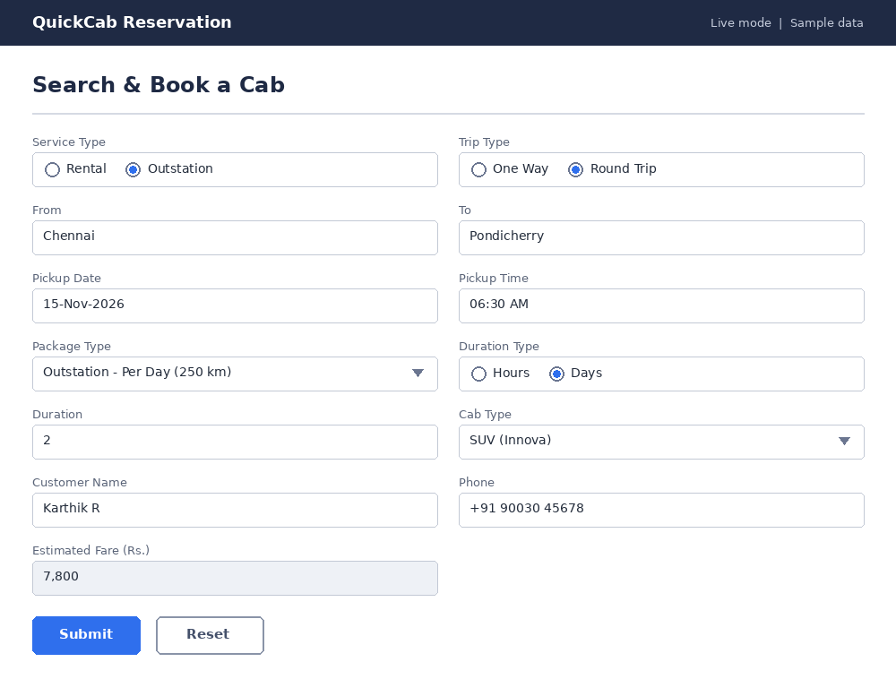
Output 2: Cab Bookings Report
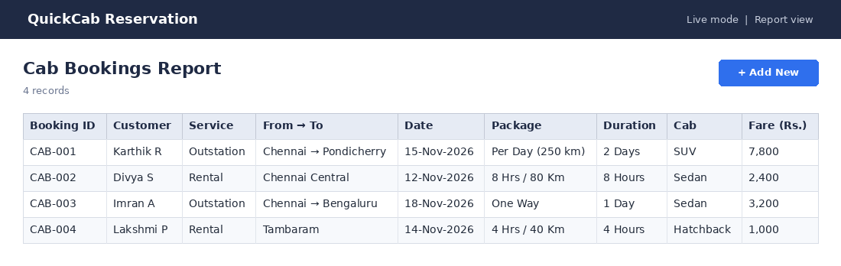

Result
Thus, the Car Booking Reservation System application was created and executed successfully on Zoho Creator. It was accessed through a web browser without any local installation, demonstrating the Software as a Service (SaaS) model.

Experiment 4: Library Book Reservation System (SIMATS Library)

Aim
To create a simple cloud software application for a Library book reservation system for the SIMATS library using Zoho Creator as the Cloud Service Provider to demonstrate the SaaS model, including the necessary fields such as Title of the book, Author, Publications, Year, Edition, No. of copies, Rack No and Status (taken/returned).

Application design
Form: Book_Master
S.No | Field Label | Field Type | Sample Value
1 | Book ID | Formula (read-only) | BK-0005
2 | Title of the Book | Single Line | Operating System Concepts
3 | Author | Single Line | Abraham Silberschatz et al.
4 | Publications | Single Line | Wiley
5 | Year | Single Line | 2018
6 | Edition | Single Line | 10th
7 | No. of Copies | Single Line | 6
8 | Rack No | Single Line | R-04
9 | Status | Radio | Available
Form: Book_Issue
S.No | Field Label | Field Type | Sample Value
1 | Register No | Single Line | 192524101
2 | Student Name | Single Line | Ravi Kumar
3 | Book | Dropdown | Computer Networks
4 | Issue Date | Single Line | 05-Oct-2026
5 | Due Date | Formula (read-only) | 19-Oct-2026
6 | Return Date | Single Line
7 | Status | Radio | Taken

Procedure
- Sign in to Zoho Creator (creator.zoho.com / creator.zoho.in), click Create Application, choose "Create from scratch" and name it "SIMATS Library".
- Create a new form named Book_Master and drag and drop the fields listed in the table for this form. Mark calculated fields as read-only. Click Save.
- Create a new form named Book_Issue and drag and drop the fields listed in the table for this form. Mark calculated fields as read-only. Click Save.
- Add the Deluge script "On Success of Book_Issue: update stock and due date" in the Form Builder under Workflow (Script Builder), as shown in the script section below.
- Click "Access Application" to open Live mode and enter the sample records in each form.
- Open the auto-generated reports and verify that the data, calculated fields and totals are correct.
- Use the Share / Publish option to create a permalink, then open it in a browser to show that the application runs as SaaS in the cloud.

Deluge scripts
On Success of Book_Issue: update stock and due date
bk = Book_Master[ID == input.Book];
if (input.Status == "Taken")
{
bk.Copies_Available = bk.Copies_Available - 1;
input.Due_Date = input.Issue_Date.addDay(14);
if (bk.Copies_Available == 0)
{
bk.Status = "Taken";
}
}
else
{
bk.Copies_Available = bk.Copies_Available + 1;
bk.Status = "Returned";
}

Books are issued for 14 days. Status changes to Taken when all copies are issued and to Returned when a copy comes back.

Output
Output 1: Add Book form (sample entry)
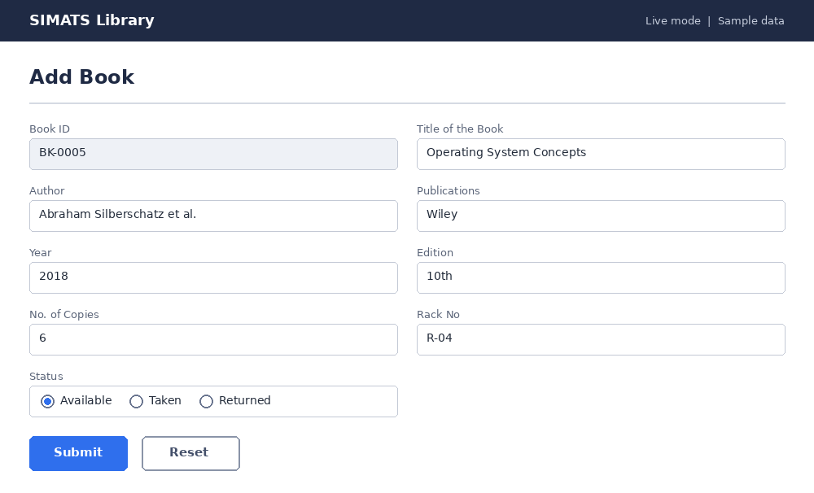
Output 2: Issue / Return Book form (sample entry)
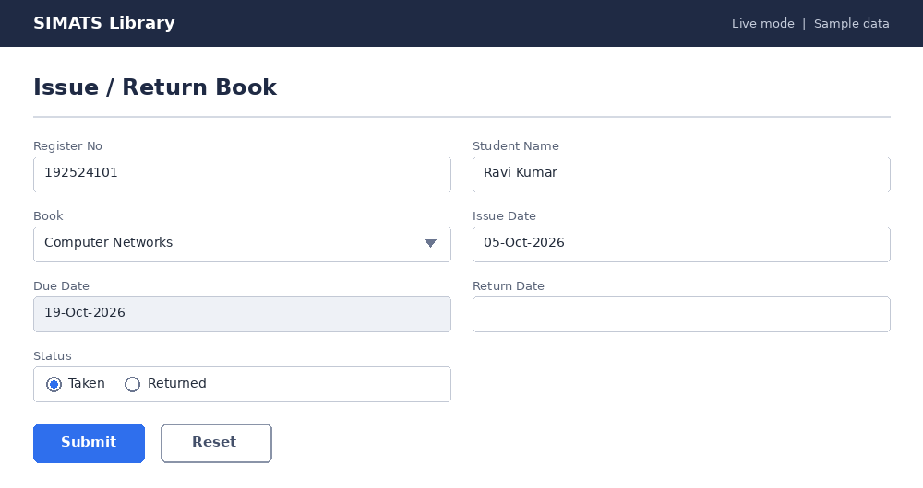
Output 3: Book Details Report
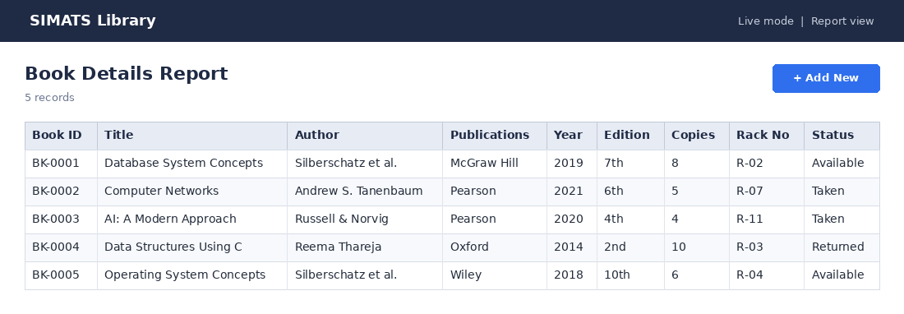
Output 4: Book Issue Report
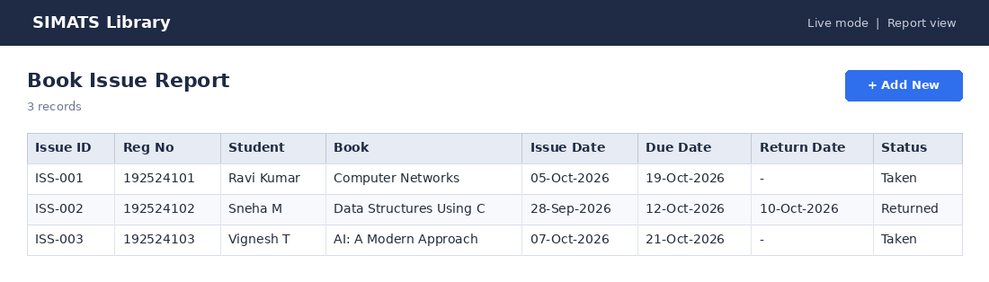

Result
Thus, the Library Book Reservation System (SIMATS Library) application was created and executed successfully on Zoho Creator. It was accessed through a web browser without any local installation, demonstrating the Software as a Service (SaaS) model.

Experiment 5: Mark Sheet Processing System

Aim
To create a simple cloud software application for a Mark Sheet Processing System using Zoho Creator as the Cloud Service Provider to demonstrate the SaaS model, including the necessary fields such as name of the student, Reg No, Subjects, Marks, Average, percentage, rank and overall performance.

Application design
Form: Mark_Sheet
S.No | Field Label | Field Type | Sample Value
1 | Name of the Student | Single Line | Arun Kumar
2 | Register No | Single Line | 192524201
3 | Mathematics | Single Line | 88
4 | Physics | Single Line | 76
5 | Chemistry | Single Line | 81
6 | Data Structures | Single Line | 92
7 | C Programming | Single Line | 85
8 | Total (out of 500) | Formula (read-only) | 422
9 | Average | Formula (read-only) | 84.40
10 | Percentage | Formula (read-only) | 84.40
11 | Rank | Formula (read-only) | 2
12 | Overall Performance | Formula (read-only) | Excellent

Procedure
- Sign in to Zoho Creator (creator.zoho.com / creator.zoho.in), click Create Application, choose "Create from scratch" and name it "SIMATS Mark Sheet Processing".
- Create a new form named Mark_Sheet and drag and drop the fields listed in the table for this form. Mark calculated fields as read-only. Click Save.
- Add the Deluge script "On Validate: total, average, percentage and performance" in the Form Builder under Workflow (Script Builder), as shown in the script section below.
- Add the Deluge script "On Success: recalculate the rank of every student" in the Form Builder under Workflow (Script Builder), as shown in the script section below.
- Click "Access Application" to open Live mode and enter the sample records in each form.
- Open the auto-generated reports and verify that the data, calculated fields and totals are correct.
- Use the Share / Publish option to create a permalink, then open it in a browser to show that the application runs as SaaS in the cloud.

Deluge scripts
On Validate: total, average, percentage and performance
input.Total = input.Mathematics + input.Physics + input.Chemistry + input.Data_Structures + input.C_Programming;
input.Average = (input.Total / 5).round(2);
input.Percentage = (input.Total * 100 / 500).round(2);
if (input.Mathematics < 40 || input.Physics < 40 || input.Chemistry < 40 || input.Data_Structures < 40 || input.C_Programming < 40)
{
input.Overall_Performance = "Fail";
}
else if (input.Percentage >= 90) { input.Overall_Performance = "Outstanding"; }
else if (input.Percentage >= 80) { input.Overall_Performance = "Excellent"; }
else if (input.Percentage >= 70) { input.Overall_Performance = "Very Good"; }
else if (input.Percentage >= 60) { input.Overall_Performance = "Good"; }
else { input.Overall_Performance = "Average"; }

On Success: recalculate the rank of every student
for each r in Mark_Sheet
{
r.Rank = Mark_Sheet[Total > r.Total].count() + 1;
}

Each subject is out of 100 (total 500). Percentage = Total x 100 / 500. A student with marks below 40 in any subject is shown as Fail. Rank is based on total marks.

Output
Output 1: Mark Sheet Entry form (sample entry)
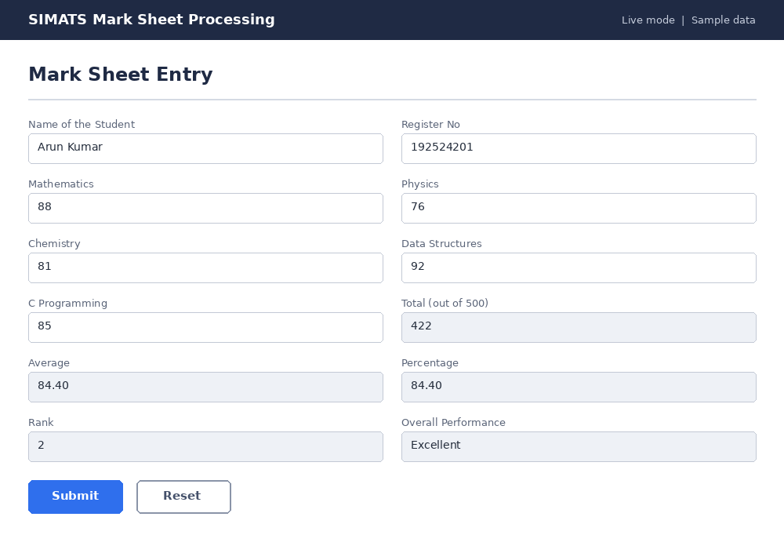
Output 2: Mark Sheet Report
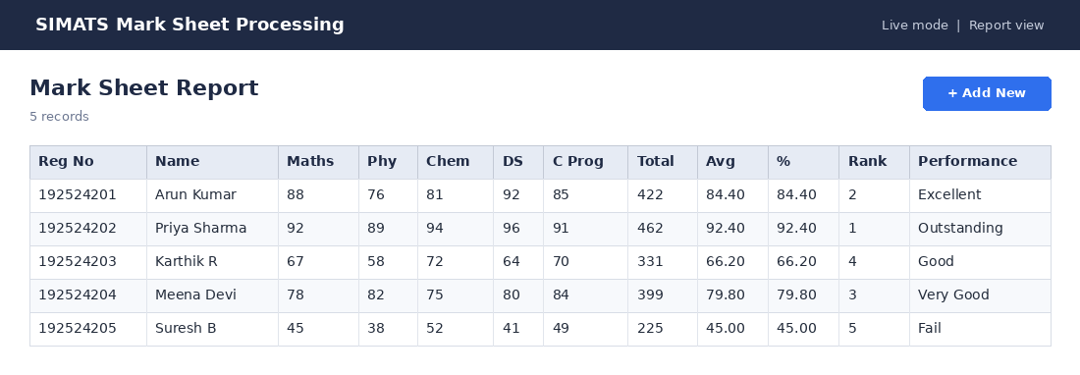

Result
Thus, the Mark Sheet Processing System application was created and executed successfully on Zoho Creator. It was accessed through a web browser without any local installation, demonstrating the Software as a Service (SaaS) model.

Experiment 6: Payroll Processing System

Aim
To create a simple cloud software application for a Payroll Processing System using Zoho Creator as the Cloud Service Provider to demonstrate the SaaS model, including the necessary fields such as Name of the employee, experience in present organisation, overall experience, basic pay, HRA, DA, TA, gross pay and net pay.

Application design
Form: Payroll
S.No | Field Label | Field Type | Sample Value
1 | Employee ID | Formula (read-only) | EMP-001
2 | Name of the Employee | Single Line | Arun Kumar
3 | Experience in Present Organisation (yrs) | Single Line | 4
4 | Overall Experience (yrs) | Single Line | 7
5 | Basic Pay (Rs.) | Single Line | 45,000
6 | HRA - 20% (Rs.) | Formula (read-only) | 9,000
7 | DA - 10% (Rs.) | Formula (read-only) | 4,500
8 | TA - 5% (Rs.) | Formula (read-only) | 2,250
9 | Gross Pay (Rs.) | Formula (read-only) | 60,750
10 | PF - 12% (Rs.) | Formula (read-only) | 5,400
11 | Professional Tax (Rs.) | Single Line | 200
12 | Net Pay (Rs.) | Formula (read-only) | 55,150

Procedure
- Sign in to Zoho Creator (creator.zoho.com / creator.zoho.in), click Create Application, choose "Create from scratch" and name it "Payroll Processing System".
- Create a new form named Payroll and drag and drop the fields listed in the table for this form. Mark calculated fields as read-only. Click Save.
- Add the Deluge script "On Validate: salary calculation" in the Form Builder under Workflow (Script Builder), as shown in the script section below.
- Click "Access Application" to open Live mode and enter the sample records in each form.
- Open the auto-generated reports and verify that the data, calculated fields and totals are correct.
- Use the Share / Publish option to create a permalink, then open it in a browser to show that the application runs as SaaS in the cloud.

Deluge scripts
On Validate: salary calculation
input.HRA = input.Basic_Pay * 0.20;
input.DA = input.Basic_Pay * 0.10;
input.TA = input.Basic_Pay * 0.05;
input.Gross_Pay = input.Basic_Pay + input.HRA + input.DA + input.TA;
input.PF = input.Basic_Pay * 0.12;
input.Net_Pay = input.Gross_Pay - input.PF - input.Professional_Tax;

Rules used: HRA = 20%, DA = 10%, TA = 5% of basic pay; Gross = Basic + HRA + DA + TA; Deductions = PF (12% of basic) + Professional Tax (Rs. 200); Net Pay = Gross - Deductions.

Output
Output 1: Employee Payroll form (sample entry)
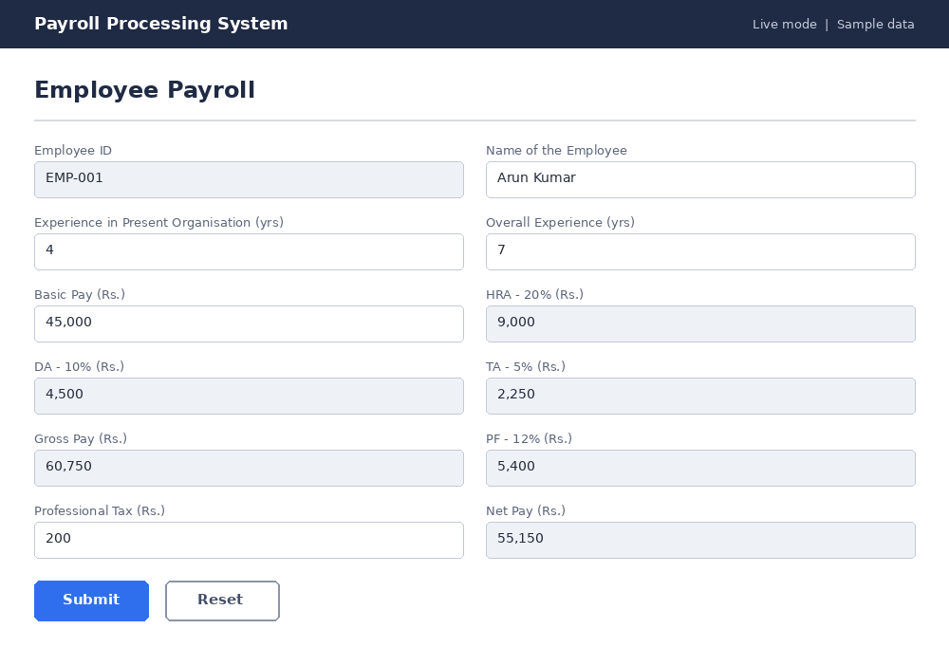
Output 2: Payroll Report (October 2026)
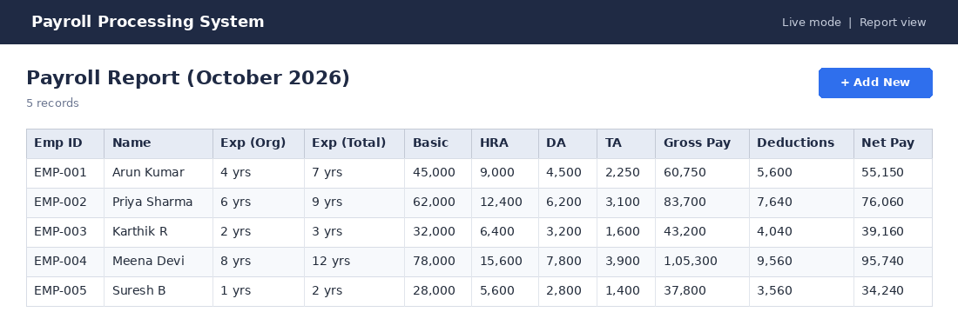

Result
Thus, the Payroll Processing System application was created and executed successfully on Zoho Creator. It was accessed through a web browser without any local installation, demonstrating the Software as a Service (SaaS) model.

Experiment 7: Students Attendance System

Aim
To create a simple cloud software application for a Students Attendance System using Zoho Creator as the Cloud Service Provider to demonstrate the SaaS model, including the necessary fields such as name of the students, course, present, absent, course attendance, OD request, grade and attendance percentage.

Application design
Form: Attendance_Entry
S.No | Field Label | Field Type | Sample Value
1 | Name of the Student | Single Line | Arun Kumar
2 | Register No | Single Line | 192524201
3 | Course | Dropdown | CSA1558
4 | Total Classes Held | Single Line | 45
5 | Present | Single Line | 40
6 | OD Days (approved) | Single Line | 2
7 | Absent | Formula (read-only) | 3
8 | Attendance Percentage | Formula (read-only) | 93.3%
9 | Grade | Formula (read-only) | A
Form: OD_Request
S.No | Field Label | Field Type | Sample Value
1 | Register No | Single Line | 192524203
2 | Student Name | Single Line | Karthik R
3 | Course | Dropdown | CSA1558
4 | OD Date | Single Line | 21-Sep-2026
5 | Reason | Multi Line | Participation in inter-college hackathon
6 | Approval Status | Radio | Approved

Procedure
- Sign in to Zoho Creator (creator.zoho.com / creator.zoho.in), click Create Application, choose "Create from scratch" and name it "SIMATS Attendance System".
- Create a new form named Attendance_Entry and drag and drop the fields listed in the table for this form. Mark calculated fields as read-only. Click Save.
- Create a new form named OD_Request and drag and drop the fields listed in the table for this form. Mark calculated fields as read-only. Click Save.
- Add the Deluge script "On Validate: absent, attendance percentage and grade" in the Form Builder under Workflow (Script Builder), as shown in the script section below.
- Click "Access Application" to open Live mode and enter the sample records in each form.
- Open the auto-generated reports and verify that the data, calculated fields and totals are correct.
- Use the Share / Publish option to create a permalink, then open it in a browser to show that the application runs as SaaS in the cloud.

Deluge scripts
On Validate: absent, attendance percentage and grade
input.Absent = input.Total_Classes - input.Present - input.OD_Days;
pct = ((input.Present + input.OD_Days) * 100 / input.Total_Classes).round(1);
input.Attendance_Percentage = pct;
if (pct >= 90) { input.Grade = "A"; }
else if (pct >= 80) { input.Grade = "B"; }
else if (pct >= 75) { input.Grade = "C"; }
else { input.Grade = "Shortage"; }

Attendance % = (Present + approved OD days) x 100 / Total classes. Grade: A (90 and above), B (80-89), C (75-79); below 75% is marked Shortage.

Output
Output 1: Course Attendance Entry form (sample entry)
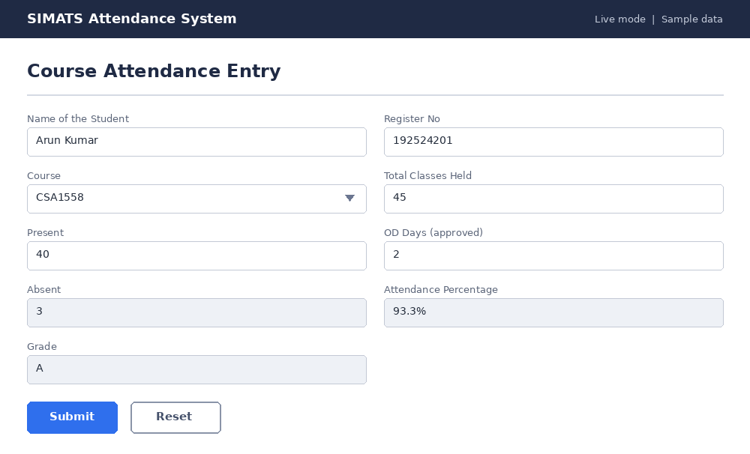
Output 2: On-Duty (OD) Request form (sample entry)
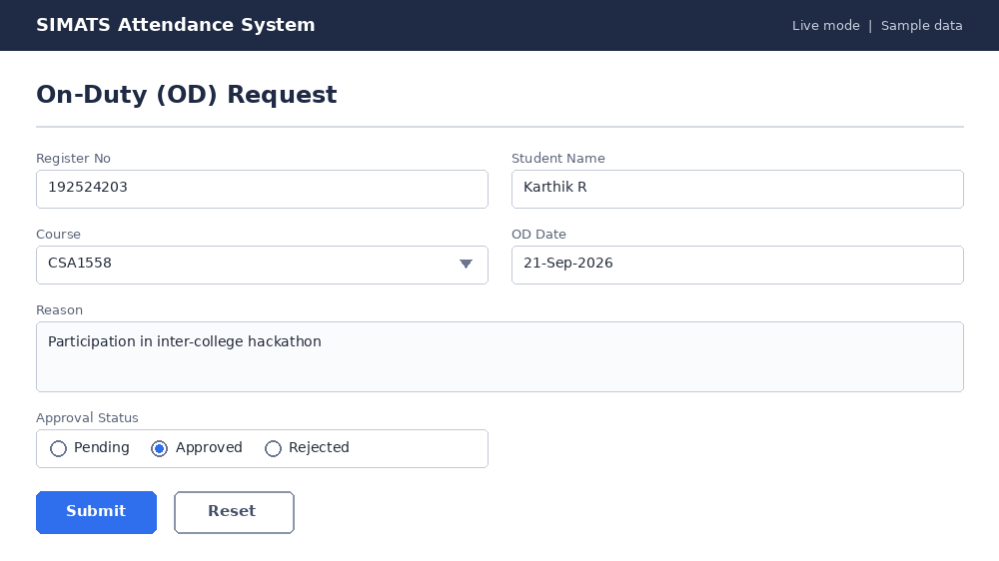
Output 3: Course Attendance Report
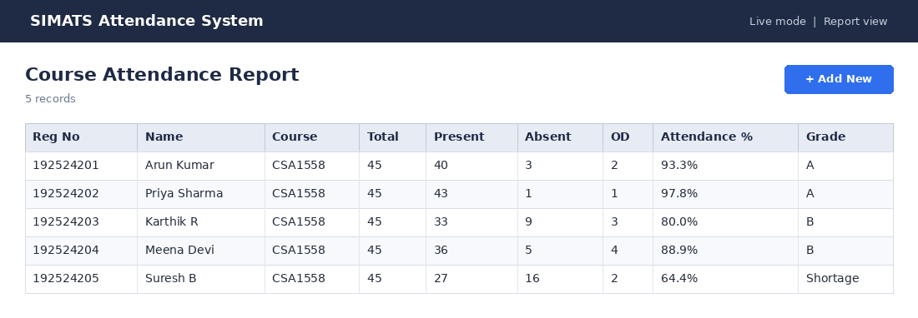
Output 4: OD Request Report
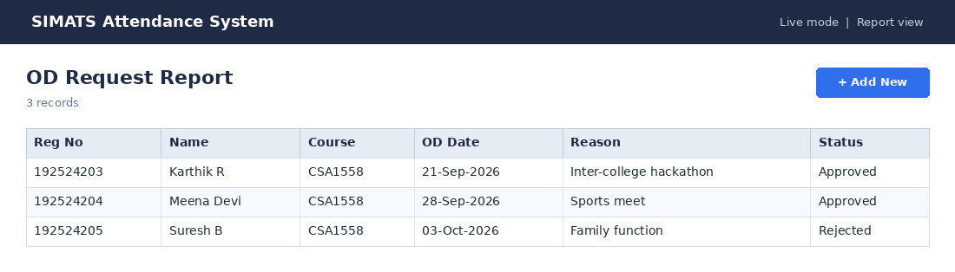

Result
Thus, the Students Attendance System application was created and executed successfully on Zoho Creator. It was accessed through a web browser without any local installation, demonstrating the Software as a Service (SaaS) model.

Experiment 8: Student Counselling System

Aim
To create a simple cloud software application for a Student Counselling System using Zoho Creator as the Cloud Service Provider to demonstrate the SaaS model, including the necessary fields such as student name, age, address, phone, subjects studied, year of passing, percentage of marks and domain interest.

Application design
Form: Student_Counselling
S.No | Field Label | Field Type | Sample Value
1 | Student Name | Single Line | Divya S
2 | Age | Single Line | 18
3 | Address | Single Line | 21, Tambaram West, Chennai - 600045
4 | Phone | Single Line | +91 98410 11223
5 | Subjects Studied | Multi Line | Physics, Chemistry, Mathematics, Computer Science
6 | Year of Passing | Single Line | 2026
7 | Percentage of Marks | Single Line | 91.5
8 | Domain Interest | Dropdown | Artificial Intelligence & Data Science
9 | Suggested Course | Formula (read-only) | B.Tech AI & Data Science
10 | Scholarship Remark | Formula (read-only) | Eligible for Merit Scholarship

Procedure
- Sign in to Zoho Creator (creator.zoho.com / creator.zoho.in), click Create Application, choose "Create from scratch" and name it "SIMATS Student Counselling".
- Create a new form named Student_Counselling and drag and drop the fields listed in the table for this form. Mark calculated fields as read-only. Click Save.
- Add the Deluge script "On Validate: suggest a course from domain interest and marks" in the Form Builder under Workflow (Script Builder), as shown in the script section below.
- Click "Access Application" to open Live mode and enter the sample records in each form.
- Open the auto-generated reports and verify that the data, calculated fields and totals are correct.
- Use the Share / Publish option to create a permalink, then open it in a browser to show that the application runs as SaaS in the cloud.

Deluge scripts
On Validate: suggest a course from domain interest and marks
if (input.Domain_Interest == "Artificial Intelligence & Data Science")
{
input.Suggested_Course = "B.Tech AI & Data Science";
}
else if (input.Domain_Interest == "Computer Science")
{
input.Suggested_Course = "B.E. Computer Science";
}
else if (input.Domain_Interest == "Biomedical")
{
input.Suggested_Course = "B.Tech Biomedical Engineering";
}
else
{
input.Suggested_Course = "B.E. Electronics / Mechanical";
}
if (input.Percentage_of_Marks >= 90)
{
input.Scholarship_Remark = "Eligible for Merit Scholarship";
}

The counsellor selects the student's domain interest and the application suggests a matching programme. Students scoring 90% or above are flagged for a merit scholarship (sample rule).

Output
Output 1: Student Counselling Form form (sample entry)
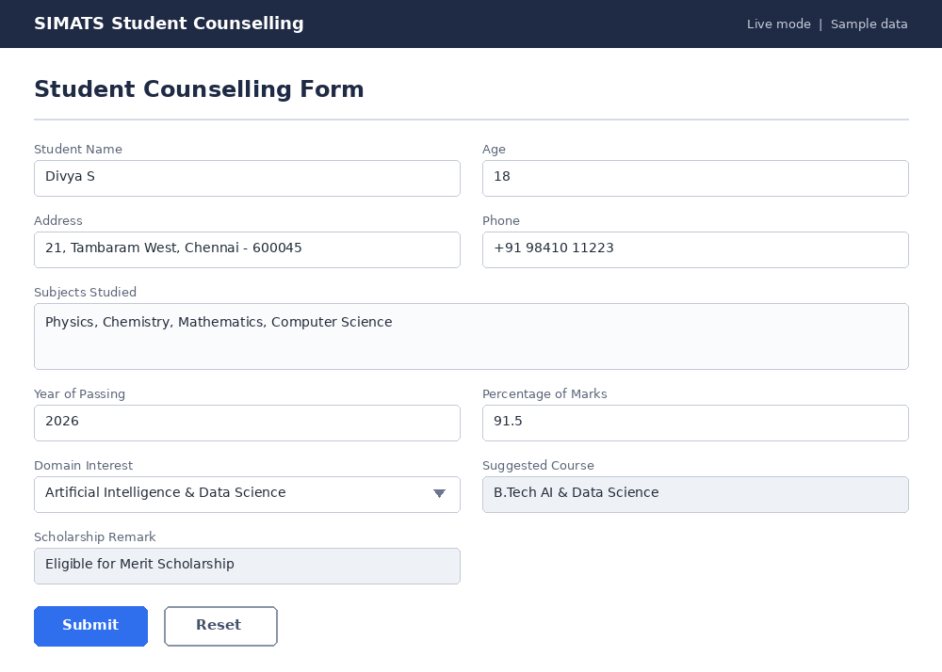
Output 2: Counselling Report
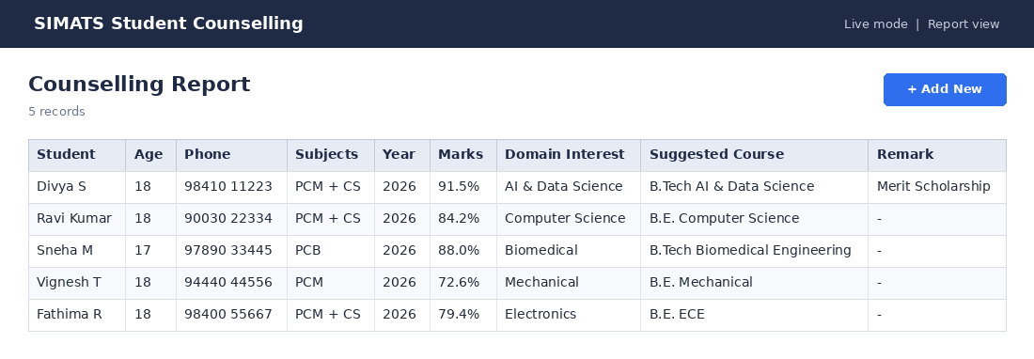

Result
Thus, the Student Counselling System application was created and executed successfully on Zoho Creator. It was accessed through a web browser without any local installation, demonstrating the Software as a Service (SaaS) model.

Experiment 9: Hospital Information System (SIMATS Hospital)

Aim
To create a simple cloud software application for a Hospital Information System for SIMATS Hospital using Zoho Creator as the Cloud Service Provider to demonstrate the SaaS model, including the necessary fields such as patient name, age, address, phone, email, attender name, attender phone, doctor name and diseases.

Application design
Form: Patient_Registration
S.No | Field Label | Field Type | Sample Value
1 | Patient ID | Formula (read-only) | PAT-001
2 | Patient Name | Single Line | Ravi Shankar
3 | Age | Single Line | 45
4 | Gender | Radio | Male
5 | Address | Single Line | 15, Thandalam Road, Chennai - 602105
6 | Phone | Single Line | +91 98400 11122
7 | Email | Single Line | ravi.shankar@example.com
8 | Admission Date | Single Line | 10-Oct-2026
9 | Attender Name | Single Line | Latha R
10 | Attender Phone | Single Line | +91 98400 11133
11 | Department | Dropdown | General Medicine
12 | Doctor Name | Dropdown | Dr. R. Venkatesh
13 | Disease / Diagnosis | Multi Line | Viral Fever

Procedure
- Sign in to Zoho Creator (creator.zoho.com / creator.zoho.in), click Create Application, choose "Create from scratch" and name it "SIMATS Hospital Information System".
- Create a new form named Patient_Registration and drag and drop the fields listed in the table for this form. Mark calculated fields as read-only. Click Save.
- Add the Deluge script "On Success: send registration confirmation by e-mail" in the Form Builder under Workflow (Script Builder), as shown in the script section below.
- Click "Access Application" to open Live mode and enter the sample records in each form.
- Open the auto-generated reports and verify that the data, calculated fields and totals are correct.
- Use the Share / Publish option to create a permalink, then open it in a browser to show that the application runs as SaaS in the cloud.

Deluge scripts
On Success: send registration confirmation by e-mail
sendmail
[
from : zoho.adminuserid
to : input.Email
subject : "Registration confirmed - SIMATS Hospital"
message : "Dear " + input.Patient_Name + ", your registration (" + input.Patient_ID + ") is confirmed. Doctor: " + input.Doctor_Name + "."
]

The Doctor Name field is a lookup to the Doctor_Master form, filtered by Department. Names in the sample data are fictitious.

Output
Output 1: Patient Registration form (sample entry)
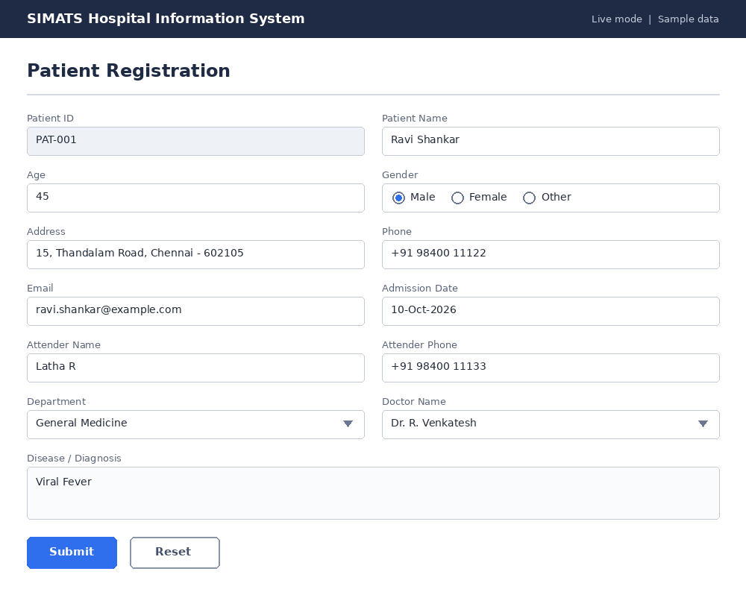
Output 2: Patient Details Report
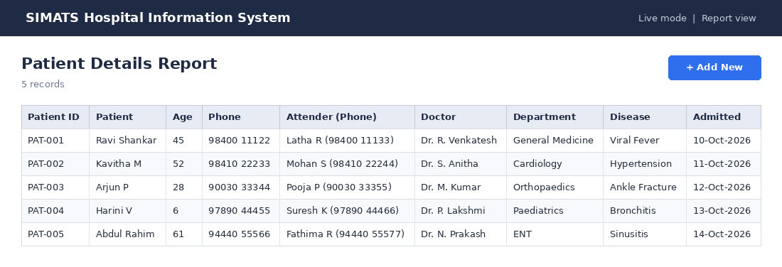

Result
Thus, the Hospital Information System (SIMATS Hospital) application was created and executed successfully on Zoho Creator. It was accessed through a web browser without any local installation, demonstrating the Software as a Service (SaaS) model.

Experiment 10: Student Information using a C Program

Aim
To create a simple cloud software application for running a C program to display student information using Zoho Creator as the Cloud Service Provider to demonstrate the SaaS model, including the necessary fields such as student name, Reg No, address, phone, age, courses, grades, attendance report, progress report and semester mark sheet.

Application design
Form: Student_Info
S.No | Field Label | Field Type | Sample Value
1 | Student Name | Single Line | Arun Kumar
2 | Register No | Single Line | 192524201
3 | Address | Single Line | 12, Gandhi St, Chennai
4 | Phone | Single Line | +91 98765 43210
5 | Age | Single Line | 19
6 | Course | Dropdown | B.Tech AI & DS
7 | Attendance Report (%) | Single Line | 93.3
8 | Overall Grade | Formula (read-only) | A+
9 | Progress Report | Formula (read-only) | Good progress
Form: Semester_Marksheet
S.No | Field Label | Field Type | Sample Value
1 | Register No | Single Line | 192524201
2 | Semester | Dropdown | Semester 1
3 | Mathematics | Single Line | 88
4 | Physics | Single Line | 76
5 | Chemistry | Single Line | 81
6 | Data Structures | Single Line | 92
7 | C Programming | Single Line | 85
8 | Total | Formula (read-only) | 422
9 | GPA | Formula (read-only) | 9.00

Procedure
- Sign in to Zoho Creator (creator.zoho.com / creator.zoho.in), click Create Application, choose "Create from scratch" and name it "SIMATS Student Information".
- Create a new form named Student_Info and drag and drop the fields listed in the table for this form. Mark calculated fields as read-only. Click Save.
- Create a new form named Semester_Marksheet and drag and drop the fields listed in the table for this form. Mark calculated fields as read-only. Click Save.
- Add the Deluge script "On Success: call the cloud-hosted C program and store its output" in the Form Builder under Workflow (Script Builder), as shown in the script section below.
- Click "Access Application" to open Live mode and enter the sample records in each form.
- Open the auto-generated reports and verify that the data, calculated fields and totals are correct.
- Use the Share / Publish option to create a permalink, then open it in a browser to show that the application runs as SaaS in the cloud.

Deluge scripts
On Success: call the cloud-hosted C program and store its output
// The compiled C program is exposed as an HTTPS endpoint (cloud function).
// Replace the URL below with your own endpoint.
response = invokeurl
[
url : "https://<your-cloud-function-url>/student-report?regno=" + input.Register_No
type : GET
];
input.Progress_Report = response;

Zoho Creator cannot compile or run C code directly. The C program is compiled and run on a cloud compiler or cloud function, and the Zoho Creator application stores and displays the student data and the program's report. The console output shown below is the real output of the program in this document.

C program
C program (student.c)
#include <stdio.h>
#include <string.h>

#define SUBJECTS 5

struct Student {
char name[30];
char regno[12];
char address[40];
char phone[15];
int age;
char course[32];
float attendance;
int marks[SUBJECTS];
};

const char *subjects[SUBJECTS] = {"Maths", "Physics", "Chemistry", "DataStruct", "C Program"};

const char *grade(int m) {
if (m >= 90) return "O";
if (m >= 80) return "A+";
if (m >= 70) return "A";
if (m >= 60) return "B+";
if (m >= 50) return "B";
if (m >= 40) return "C";
return "F";
}

int points(int m) {
if (m >= 90) return 10;
if (m >= 80) return 9;
if (m >= 70) return 8;
if (m >= 60) return 7;
if (m >= 50) return 6;
if (m >= 40) return 5;
return 0;
}

const char *progress(float avg) {
if (avg >= 85) return "Excellent progress";
if (avg >= 70) return "Good progress";
if (avg >= 50) return "Satisfactory";
return "Needs improvement";
}

int main(void) {
struct Student s[3] = {
{"Arun Kumar", "192524201", "12, Gandhi St, Chennai", "9876543210", 19, "B.Tech AI & DS", 93.3f, {88, 76, 81, 92, 85}},
{"Priya Sharma", "192524202", "45, Anna Nagar, Chennai", "9840011223", 18, "B.Tech AI & DS", 97.8f, {92, 89, 94, 96, 91}},
{"Karthik R", "192524203", "7, Tambaram, Chennai", "9003045678", 19, "B.Tech AI & DS", 80.0f, {67, 58, 72, 64, 70}}
};
int i, j;

printf("========== STUDENT INFORMATION ==========\n");
for (i = 0; i < 3; i++) {
printf("Name : %s\n", s[i].name);
printf("Reg No : %s\n", s[i].regno);
printf("Address : %s\n", s[i].address);
printf("Phone : %s\n", s[i].phone);
printf("Age : %d\n", s[i].age);
printf("Course : %s\n\n", s[i].course);
}

printf("========== ATTENDANCE REPORT ==========\n");
printf("%-14s %-10s %-12s %s\n", "Name", "Reg No", "Attendance", "Status");
for (i = 0; i < 3; i++)
printf("%-14s %-10s %9.1f%% %s\n", s[i].name, s[i].regno, s[i].attendance,
s[i].attendance >= 75 ? "Eligible" : "Shortage");

printf("\n========== PROGRESS REPORT ==========\n");
printf("%-14s %-8s %-9s %s\n", "Name", "Total", "Average", "Remark");
for (i = 0; i < 3; i++) {
int total = 0;
for (j = 0; j < SUBJECTS; j++) total += s[i].marks[j];
float avg = total / (float)SUBJECTS;
printf("%-14s %-8d %-9.2f %s\n", s[i].name, total, avg, progress(avg));
}

printf("\n========== SEMESTER MARK SHEET ==========\n");
for (i = 0; i < 3; i++) {
int total = 0, gp = 0;
printf("\nName: %s Reg No: %s\n", s[i].name, s[i].regno);
printf("%-12s %-6s %s\n", "Subject", "Marks", "Grade");
for (j = 0; j < SUBJECTS; j++) {
printf("%-12s %-6d %s\n", subjects[j], s[i].marks[j], grade(s[i].marks[j]));
total += s[i].marks[j];
gp += points(s[i].marks[j]);
}
printf("Total: %d GPA: %.2f\n", total, gp / (float)SUBJECTS);
}
return 0;
}

Output
Output 1: Student Information form (sample entry)
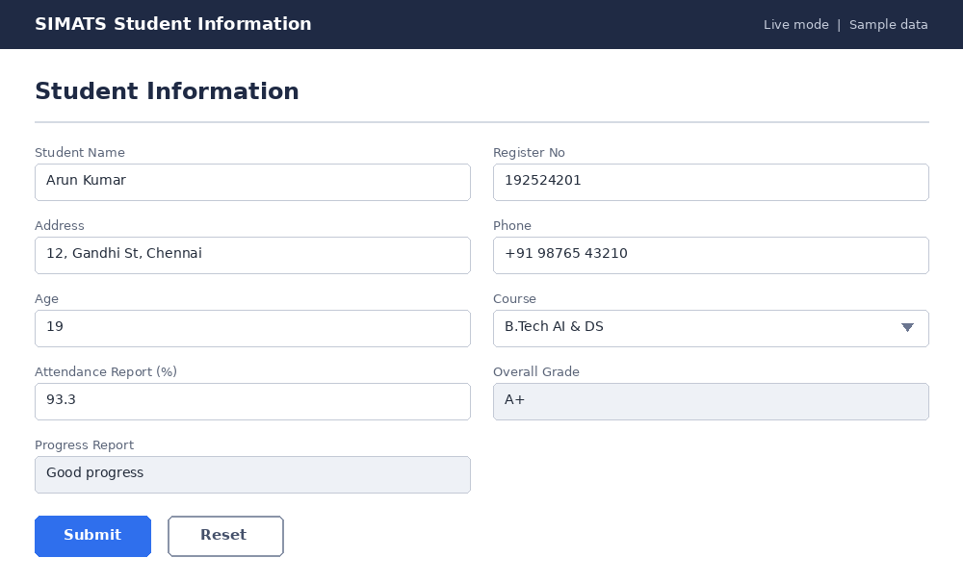
Output 2: Semester Mark Sheet form (sample entry)
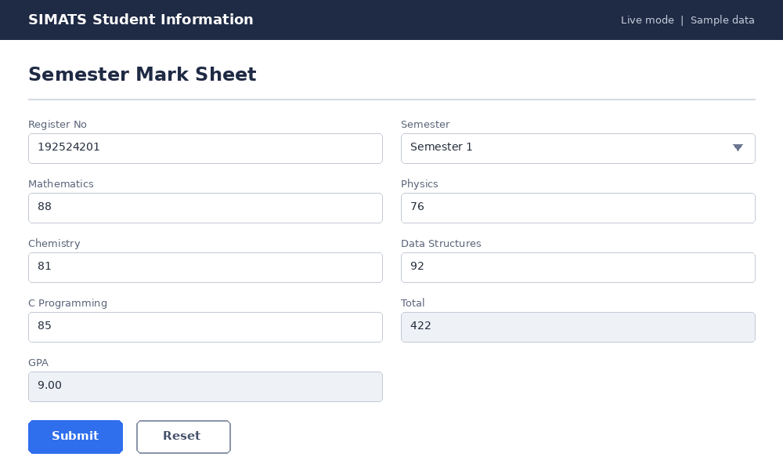
Output 3: Student Information Report
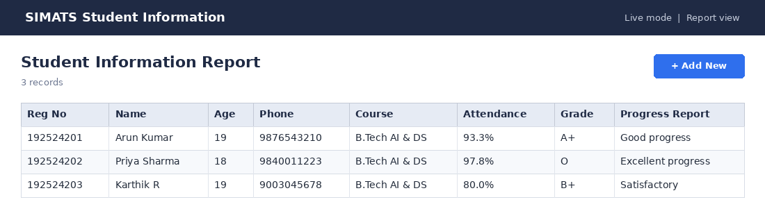
Output 4: Semester Mark Sheet Report
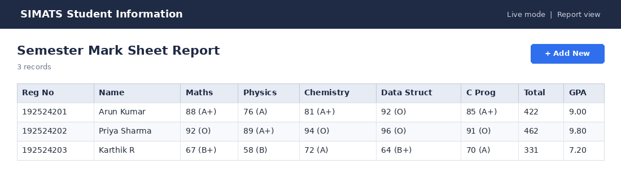
Output of the C program (compiled with gcc and executed)
========== STUDENT INFORMATION ==========
Name : Arun Kumar
Reg No : 192524201
Address : 12, Gandhi St, Chennai
Phone : 9876543210
Age : 19
Course : B.Tech AI & DS

Name : Priya Sharma
Reg No : 192524202
Address : 45, Anna Nagar, Chennai
Phone : 9840011223
Age : 18
Course : B.Tech AI & DS

Name : Karthik R
Reg No : 192524203
Address : 7, Tambaram, Chennai
Phone : 9003045678
Age : 19
Course : B.Tech AI & DS

========== ATTENDANCE REPORT ==========
Name Reg No Attendance Status
Arun Kumar 192524201 93.3% Eligible
Priya Sharma 192524202 97.8% Eligible
Karthik R 192524203 80.0% Eligible

========== PROGRESS REPORT ==========
Name Total Average Remark
Arun Kumar 422 84.40 Good progress
Priya Sharma 462 92.40 Excellent progress
Karthik R 331 66.20 Satisfactory

========== SEMESTER MARK SHEET ==========

Name: Arun Kumar Reg No: 192524201
Subject Marks Grade
Maths 88 A+
Physics 76 A
Chemistry 81 A+
DataStruct 92 O
C Program 85 A+
Total: 422 GPA: 9.00

Name: Priya Sharma Reg No: 192524202
Subject Marks Grade
Maths 92 O
Physics 89 A+
Chemistry 94 O
DataStruct 96 O
C Program 91 O
Total: 462 GPA: 9.80

Name: Karthik R Reg No: 192524203
Subject Marks Grade
Maths 67 B+
Physics 58 B
Chemistry 72 A
DataStruct 64 B+
C Program 70 A
Total: 331 GPA: 7.20

Result
Thus, the Student Information using a C Program application was created and executed successfully on Zoho Creator. It was accessed through a web browser without any local installation, demonstrating the Software as a Service (SaaS) model.

Experiment 11: Online Super Market

Aim
To create a simple cloud software application for an Online Super Market using Zoho Creator as the Cloud Service Provider to demonstrate the SaaS model, including the necessary fields such as customer name, address, phone, email, items, quantity and the item classification form.

Application design
Form: Item_Classification
S.No | Field Label | Field Type | Sample Value
1 | Category Code | Formula (read-only) | CAT-006
2 | Category Name | Dropdown | Snacks
3 | Sub Category | Single Line | Biscuits & Cookies
4 | Status | Radio | Active
5 | Description | Multi Line | Packed biscuits, cookies and tea-time snacks
Form: Item_Master
S.No | Field Label | Field Type | Sample Value
1 | Item ID | Formula (read-only) | ITM-006
2 | Item Name | Single Line | Digestive Biscuits
3 | Category | Dropdown | Snacks - Biscuits & Cookies
4 | Brand | Single Line | Sunfeast
5 | Unit | Dropdown | Packet
6 | Price (Rs.) | Single Line | 35.00
7 | Stock Available | Single Line | 150
Form: Customer_Order
S.No | Field Label | Field Type | Sample Value
1 | Order No | Formula (read-only) | ORD-001
2 | Customer Name | Single Line | Arun Kumar
3 | Address | Single Line | 12, Gandhi Street, Chennai - 600077
4 | Phone | Single Line | +91 98765 43210
5 | Email | Single Line | arun.kumar@example.com
6 | Order Date | Single Line | 14-Oct-2026
7 | Order Items (Subform) | Subform | Subform (see output)
8 | Payment Mode | Radio | UPI
9 | Delivery Type | Radio | Home Delivery
10 | Total Amount (Rs.) | Formula (read-only) | 779.00

Procedure
- Sign in to Zoho Creator (creator.zoho.com / creator.zoho.in), click Create Application, choose "Create from scratch" and name it "Online Super Market".
- Create a new form named Item_Classification and drag and drop the fields listed in the table for this form. Mark calculated fields as read-only. Click Save.
- Create a new form named Item_Master and drag and drop the fields listed in the table for this form. Mark calculated fields as read-only. Click Save.
- Create a new form named Customer_Order and drag and drop the fields listed in the table for this form. Mark calculated fields as read-only. Click Save.
- Add the Deluge script "On User Input of Item / Quantity (subform): price and line amount" in the Form Builder under Workflow (Script Builder), as shown in the script section below.
- Add the Deluge script "On Validate of Customer_Order: total bill" in the Form Builder under Workflow (Script Builder), as shown in the script section below.
- Click "Access Application" to open Live mode and enter the sample records in each form.
- Open the auto-generated reports and verify that the data, calculated fields and totals are correct.
- Use the Share / Publish option to create a permalink, then open it in a browser to show that the application runs as SaaS in the cloud.

Deluge scripts
On User Input of Item / Quantity (subform): price and line amount
if (row.Item != null)
{
itemRec = Item_Master[ID == row.Item];
row.Unit_Price = itemRec.Price;
row.Amount = row.Unit_Price * ifnull(row.Quantity, 0);
}

On Validate of Customer_Order: total bill
total = 0;
for each line in input.Order_Items
{
total = total + ifnull(line.Amount, 0);
}
input.Total_Amount = total;

Output
Output 1: Item Classification form (sample entry)
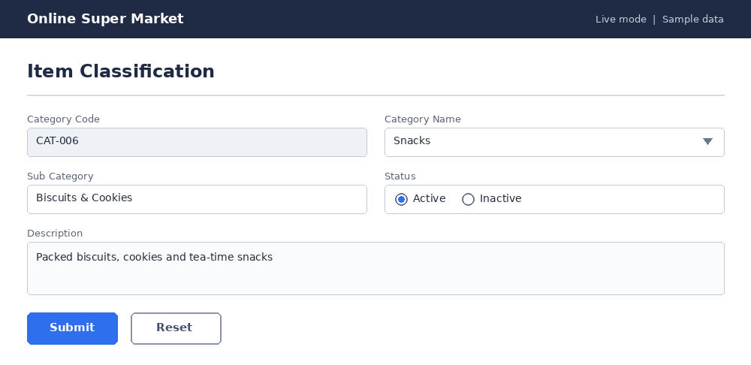
Output 2: Item Master form (sample entry)
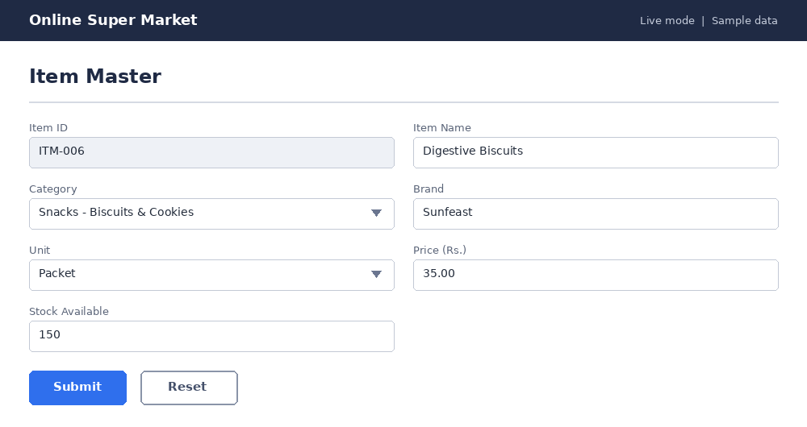
Output 3: Customer Order form (sample entry)
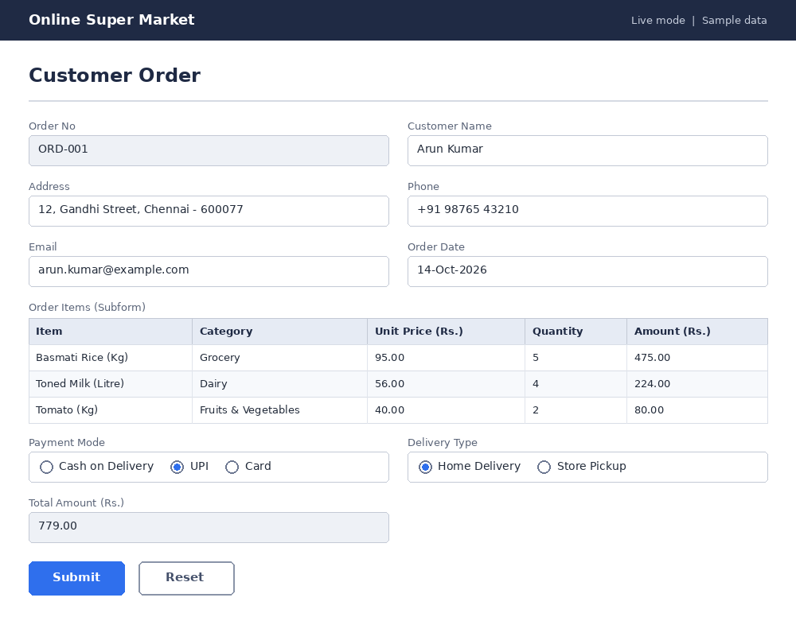
Output 4: Item Classification Report
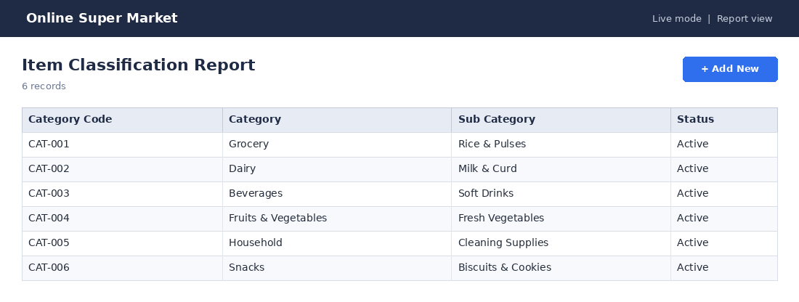
Output 5: Customer Orders Report
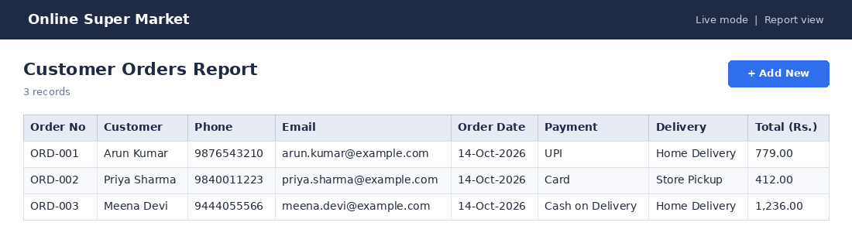

Result
Thus, the Online Super Market application was created and executed successfully on Zoho Creator. It was accessed through a web browser without any local installation, demonstrating the Software as a Service (SaaS) model.

